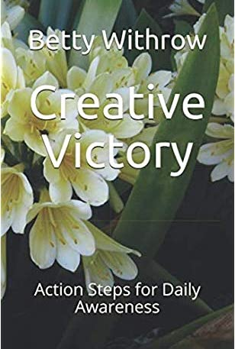

Welcome to Creative Victory!

This book is a companion to the book I wrote about finding ways to turn anything that happens into a tool for your success:

Prevail: Seven Keys to Create A Personal Victory.

This book is your action guide.
It builds on the concept of the Seven Keys to Victory, which are outlined in greater detail in the original book.

In this volume, you will find daily action steps to increase your awareness of your surroundings and of yourself, so that you can create more of what you want out of life. I use parts of it in my live workshops and personal coaching. It will serve as a guide for your journey. Don’t rush through it. Make it something you can truly enjoy.

If you would like to know more about what I do to support creative people and authors, please visit my web site at

www.thewriterslaunchpad.com.

With all my best, always,

Betty Withrow

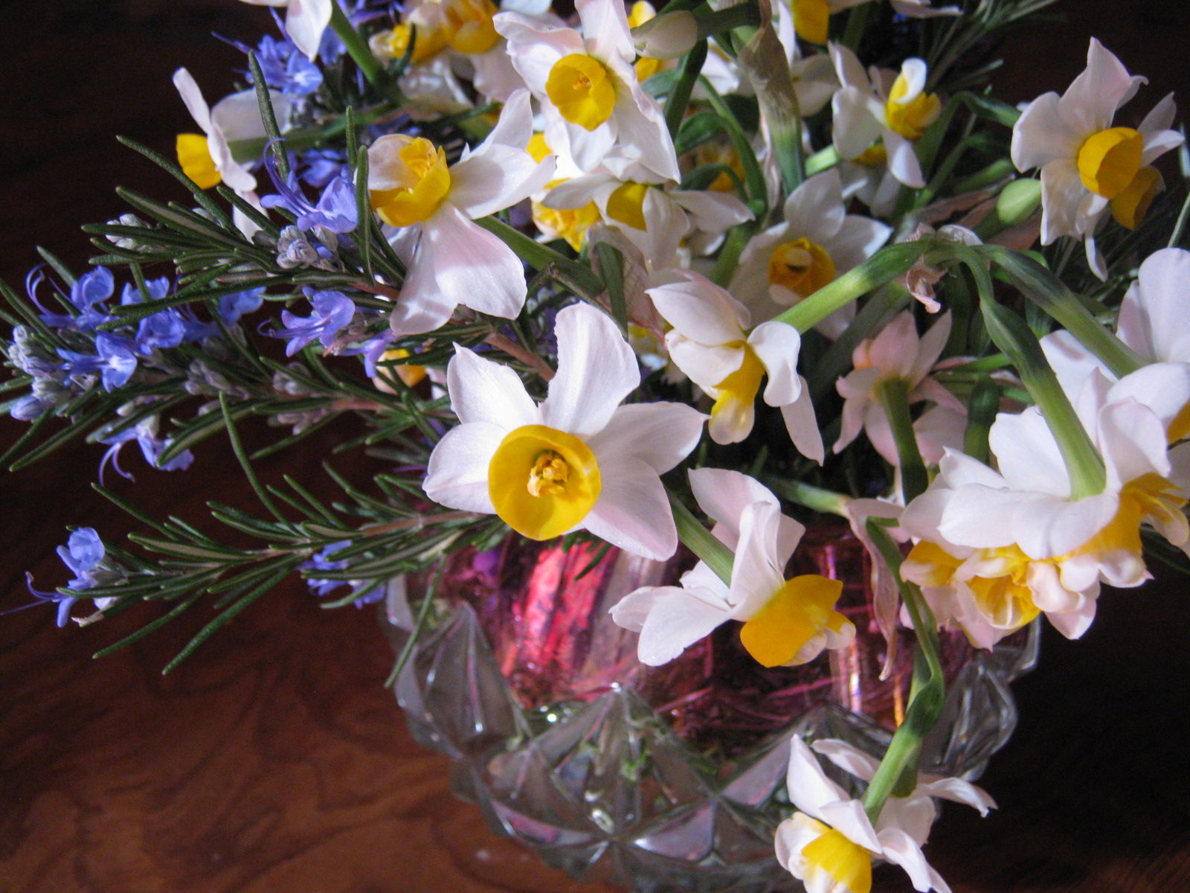

Cheer up: It’s the Best Idea Around

Action steps for Cheerfulness

What is coming up for you right now
about your situation in life?

What do you want to celebrate?

What is taking your attention the most?

Who is your energy serving?

In ten words or less, what challenges are you seeing as most important? List five. Circle one word from each challenge that has the most power in your mind.

1.________________________________________________________

2.________________________________________________________

3.________________________________________________________

4.________________________________________________________

5.________________________________________________________

How do these words affect your feelings about the challenges?

Which challenge holds the most power in your mind (urgency, importance, emotional impact, etc.)

What is it that makes this challenge important?

What is the closest point it holds to your life as it is, now?

Where do you feel this challenge within your body?

What color do you see when you think about it?

Place the word you chose within the color, and visualize it interacting with the challenge.

How does the word you chose light up your perception of this challenge?

What action can you take to bring this word forward in your perception of the situation?


What is it that makes you happy about this challenge?

Or what makes you sad about it?

Is this authentic to your vision of who you want to become?

Are these your most authentic feelings, or are they a reflection of how you ”think you should feel”?

What would you rather feel about this?

Is there an action you can take today to create incremental change? (For example, change a daily habit a little at a time)
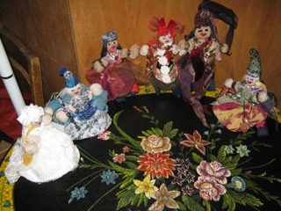

What is it?

Who can help you with this?

What is this challenge telling you about yourself?

How are you in a place of leverage to affect the way it affects your life? What’s your place of power in the situation?

How is it the doorway to a new place in your life?

Draw a quick sketch of yourself interacting with this challenge.

In ten words or less, what are the things that take up your time and are not important or interesting for you, or that drain your energy or cause you to feel unhappy?

List five.

1._________________________________________________________

2._________________________________________________________

3._________________________________________________________

4._________________________________________________________

5._________________________________________________________

What one word is most descriptive of each of them?

How is each one connected to you?

Who is involved in this connection?

Which one is the most draining of all?

List the two most important difficulties.

1._________________________________________________________

2._________________________________________________________

List the two most important hidden benefits.

1._________________________________________________________

2.__________________________________________________________

If you are sad about this, is there something in the situation to be glad about?

What makes that, the happy part of the sad part, a happy thing?

How can you expand on this feeling? Can you pass it along to someone else?

What would you need to change about your perception of yourself in order to be cheerful about the part of this that makes you sad?
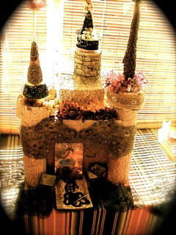

How do you make the best use of your happy moments?

How do you deal with unhappy times or situations?

What do you think you do well in difficult situations?


Affirmations to create a cheerful energy field

Choose three of these and say them aloud at least five times daily.

I am worthy of success, admiration, and victory.

Life is a friendly and pleasant place, and precious.

Good people are all around me and want to help me.

My inner worth is defined by my own standards, not those of others.

People who have hurt me are not my responsibility.

The inner light of my spirit is always there for me.

I cannot be made less by any circumstance.

As you say each one, make a conscious effort to connect it to something good that is going on right now.

Find a way to give a person a kind thought or moment without them expecting it, and know that you are expressing love for yourself, as well. You are giving value to the world! Send a message, or call someone.
Greet someone you meet with open hand and heart.



Write down the feelings you have about what is good that happens today, and tell someone about it, even if in a small way.

Complete this sentence:

“I am really ready to let go of feeling______________ and to feel_______ instead.”

Allow yourself to notice what this does to your perception of the power you have in the situation. Now make a decision.

Now complete this sentence: “I wish I could stop feeling sad about_________________.”

Now cross out “I wish”. Then cross out “could”. What’s left?
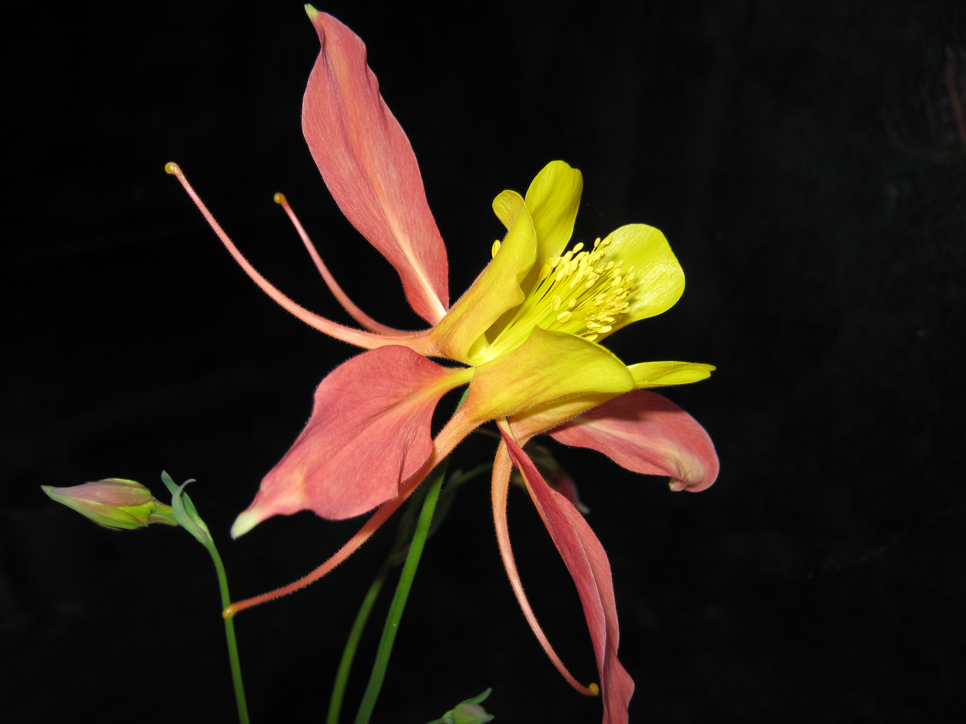

Find a clown doll or a picture of a clown. When you feel discouraged, create a conversation with the clown asking it why it’s dong this to you. Thank the clown for being ready to listen, and for being so understanding. Start an argument with the clown. After you have said your piece, make a real effort to listen to the reply.

Journaling: Fill a page with words of cheerfulness, happiness, and connection.

Get in touch with me about working further together at betty@creativevictorylifecoaching.com.

Or call me at (831) 238.2626.

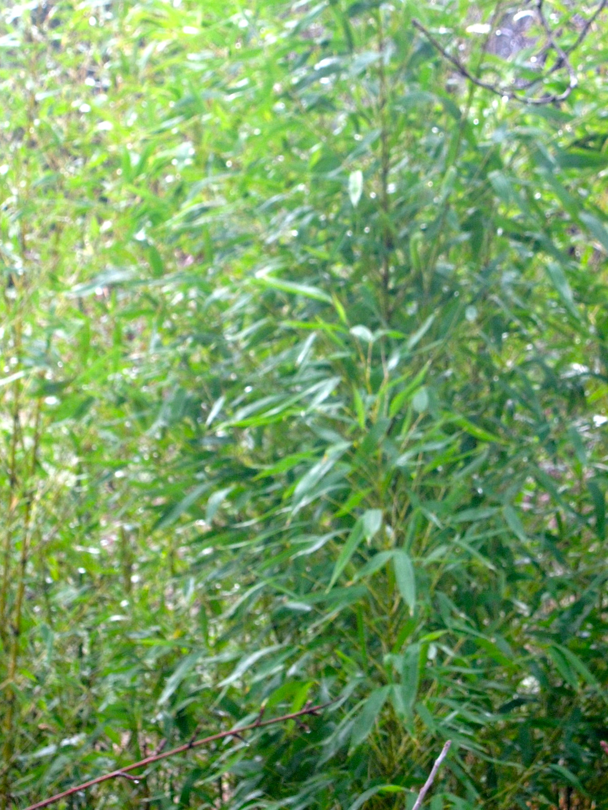

Patience:
One Breath at a Time



Action Steps for
Patience
Lots of effort goes into having the belief that you are so busy that you don’t have time to think, a popular idea in a “doing-oriented” culture, but is it really true?

Does it need to be true, for you?

How much of that busy feeling is not needed, and in fact keeps you from the essential core of your being?

Are your priorities the ones you really want, or those that others have told you are important?
List five top priorities in your life, in ten words or less.

1.___________________________________________

2.___________________________________________

3.___________________________________________

4.___________________________________________

5.___________________________________________

In five words or less, where is the priority originating? (your own needs, those of others, demands of work, etc.)

1._________________________________

2._________________________________

3._________________________________

4._________________________________

5._________________________________

What is the common thread between all of these? How are they related to you in the most direct sense?

Are you responding to false information about how important it is to ride the edge of overwhelm, through overstimulation, and a process of absorbing stimulus that is not even useful?

What does that look like for you?

Is this something you are willing to accept as it is?
What tools or skills do you have that allow you to navigate this challenge?

How can you make use of them today?

Do you have hope that this type of stimulus will change?

Are you a good listener?

How willing are you to listen to those who are telling you things that are not to your liking?

Is it important to you that other people understand your point of view and take action on your ideas?

How often do you have the feeling that things are going too fast, or too slow?
Do you often get mad at others for being either too slow, or too much in a hurry?
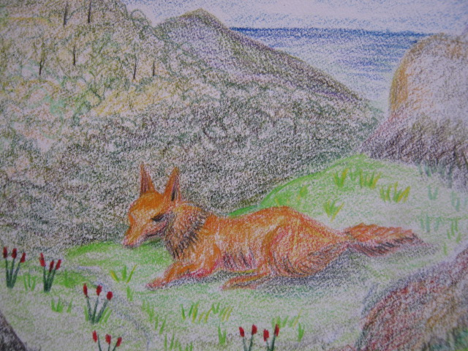

What are the five most trying situations or people for you, in terms of having enough patience?

1.___________________________________________________

____________________________________________________

2.___________________________________________________

____________________________________________________

3.___________________________________________________

____________________________________________________

4.___________________________________________________

____________________________________________________

5.___________________________________________________

What is the most difficult part of each of these? Use three words to describe it.

1.___________________
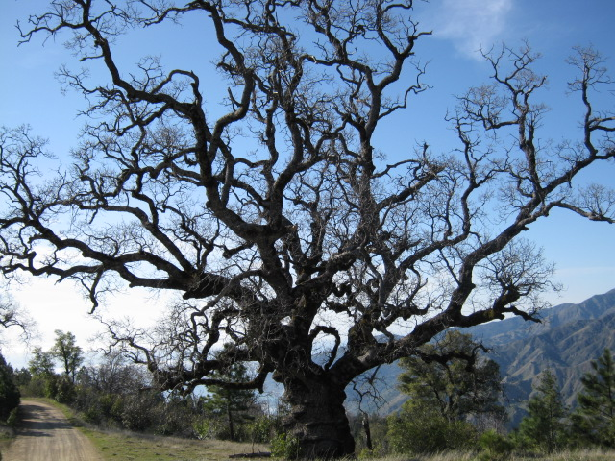

2.____________________

3.____________________

4.____________________

5.____________________

How do you feel when you look at each of them?

Step out of the event, and into the process. Where’s the point of contact for you? Is it physical, or emotional?

What is this situation telling you about your world?

As you look at each of the three-word descriptions, which of them is an active principle? This is the place where you can create choice and leverage for yourself by shifting your perceptions.

Ask yourself, “what would this be like if it was easy?” What would be different from the way it is now?

How would you think you would feel as a result?

Is there something you can shift in your basic feeling about the events you have described?

How would that affect the way other people in the situation treat you or react to your energy?

Is it possible to slow down enough to let the situation unfold without needing to control it?

What would it take to cause you to understand things in a way that was more enjoyable for you, and led to better results?

Is it something you can give to someone else, and make room for it to come to you?

How can you change your way of being in the situation, so as to make more room for the other person, and therefore for yourself?

Is this based on your interactions with others, or is it solely about your own worldview?

What is the difference between an idea that a situation is happening to you, and one that you are part of it?

How is your role created in each moment?

Complete this sentence: “______________”drives me crazy.

Now cross out the word you put into the blank and replace it with the word “nothing”.

How does that change the way you see your feelings?

Affirmations for growing patience:

Say at least three of these aloud, five times or more daily.

My life is bigger than this situation.

There is plenty of time to do what I need to do.

I am responsible for my own feelings.

I have the right to define my own vision of life and to live by it.

My energy field can be transformed by my own efforts to align with my higher message.

Help is there when I ask for it.

Asking for help is not a sign of weakness but of intelligence.

Helping others helps me, too.

Journaling: fill a page with words of patience, understanding, and compassion.

Get in touch with me about working further together at betty@creativevictorylifecoaching.com.

Or call me at (831)238.2626. Hang in there, and know you are doing good things for yourself.


The Friendly
Universe

Action Steps
For
Friendliness

Each person who comes into your life has a reason for being there, and the reason is not the same for both. You will share what is to be shared, and learn what is to be learned, with a Big Heart and Big Spirit, when you acknowledge the Divine nature of all friendships, whether or not they endure.

YOU are the friend you are going to have all your life, whoever else may come and go. Be nice to that friend. Listen to her. She has more than one precious gift for you.

Who are the friends you have today?

How did they come into your life?

What friends have you had before, who are no longer part of your life now?

How did the parting of ways come about?

Was this an active situation of change in either of your lives?

What kinds of people do you want for your friends in the future?

What do you think a friendship is all about?

What kind of friend are YOU to the people you hold as YOUR people?

What are the biggest qualities you see as important to connecting with your new friends? List five, in ten words or less.

1.___________________________________________________

2.___________________________________________________

3.___________________________________________________

4.___________________________________________________

5.___________________________________________________

What is the key word from each of the above statements?

1.__________________


2.__________________

3.__________________

4.__________________

5.__________________

What type of image comes to your mind from each of these words?

Are you an outgoing person?

Do you tend to accept things and people as they are?

Do you wait for things to come to you, or do you seek them out?

Are you a good listener?

How does it make you feel when you share something about yourself that you are not happy about?

Are you uncomfortable with letting people know you have things that are not going well?

Do you think that you are able to talk about your happy times and accomplishments in a way that makes others happy about them, too?

Do you get upset if someone doesn’t agree with the way you think about something?

List five things that are hard for you to share with others, in ten words or less.

1.__________________________________________________

2.__________________________________________________

3.__________________________________________________

4.__________________________________________________

5.__________________________________________________

What makes these difficult?

Is the problem more with how you will feel, or about how you think others will feel?

Do you listen to the problems of others well?

List from one to five how well each of the following statements feels true for you.

I don’t want to bother people with my problems._____

People will think I am weak if I don’t act happy all the time.____

Hearing other people talk about their difficulties makes me feel sorry for them.______

It just really bothers me when I hear about how happy someone else is, knowing I don’t have what they have.____

Other people will feel jealous if I share my happy times.____

What would it be like if you had a “zero” score for each of these?

How would your day be different?

The next time someone opens up to you about something that is bothering them, even if they aren’t doing it in a conscious way, make a real effort to see their situation as being something that you care about. See them, hear the message, acknowledge them (even silently, if that’s more appropriate). Then release the situation and move on. How does that feel?

Talk to someone you have never met before, in a gentle way.
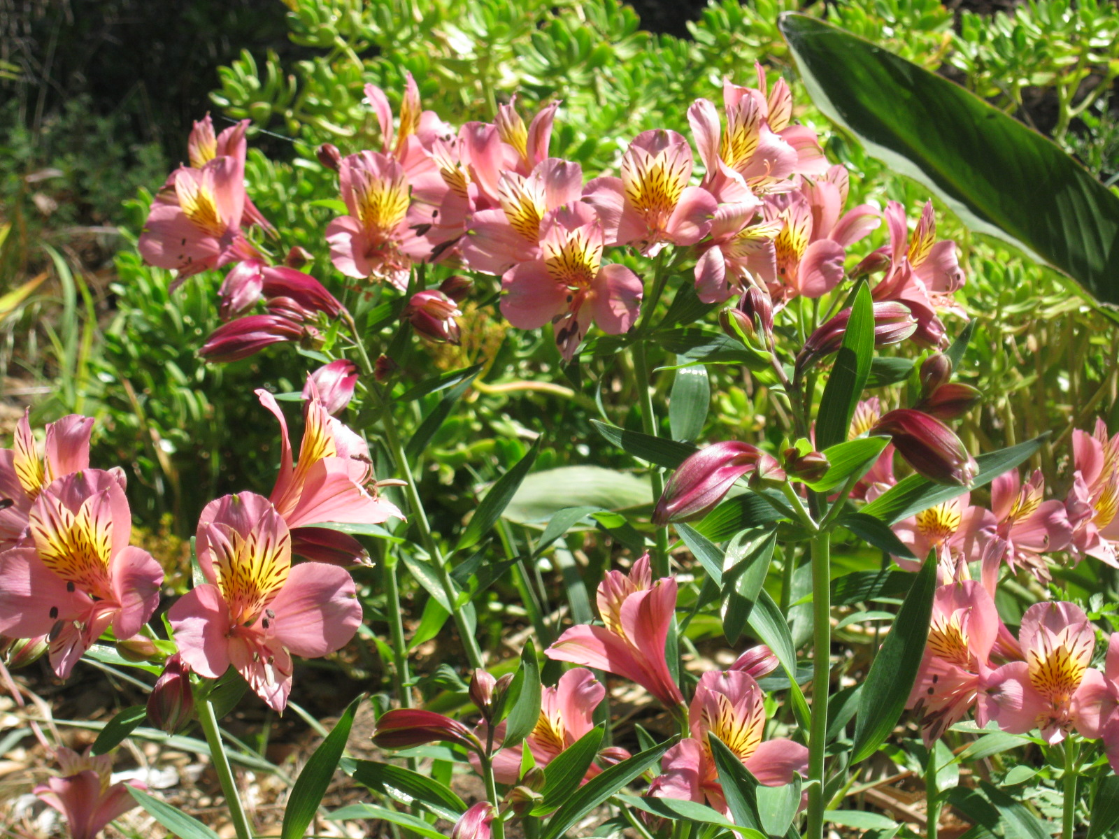
When someone is talking about being really happy about something and you don’t have that same happiness, bless the fact that they share it with you, and know that good things are waiting for you in that blessing.

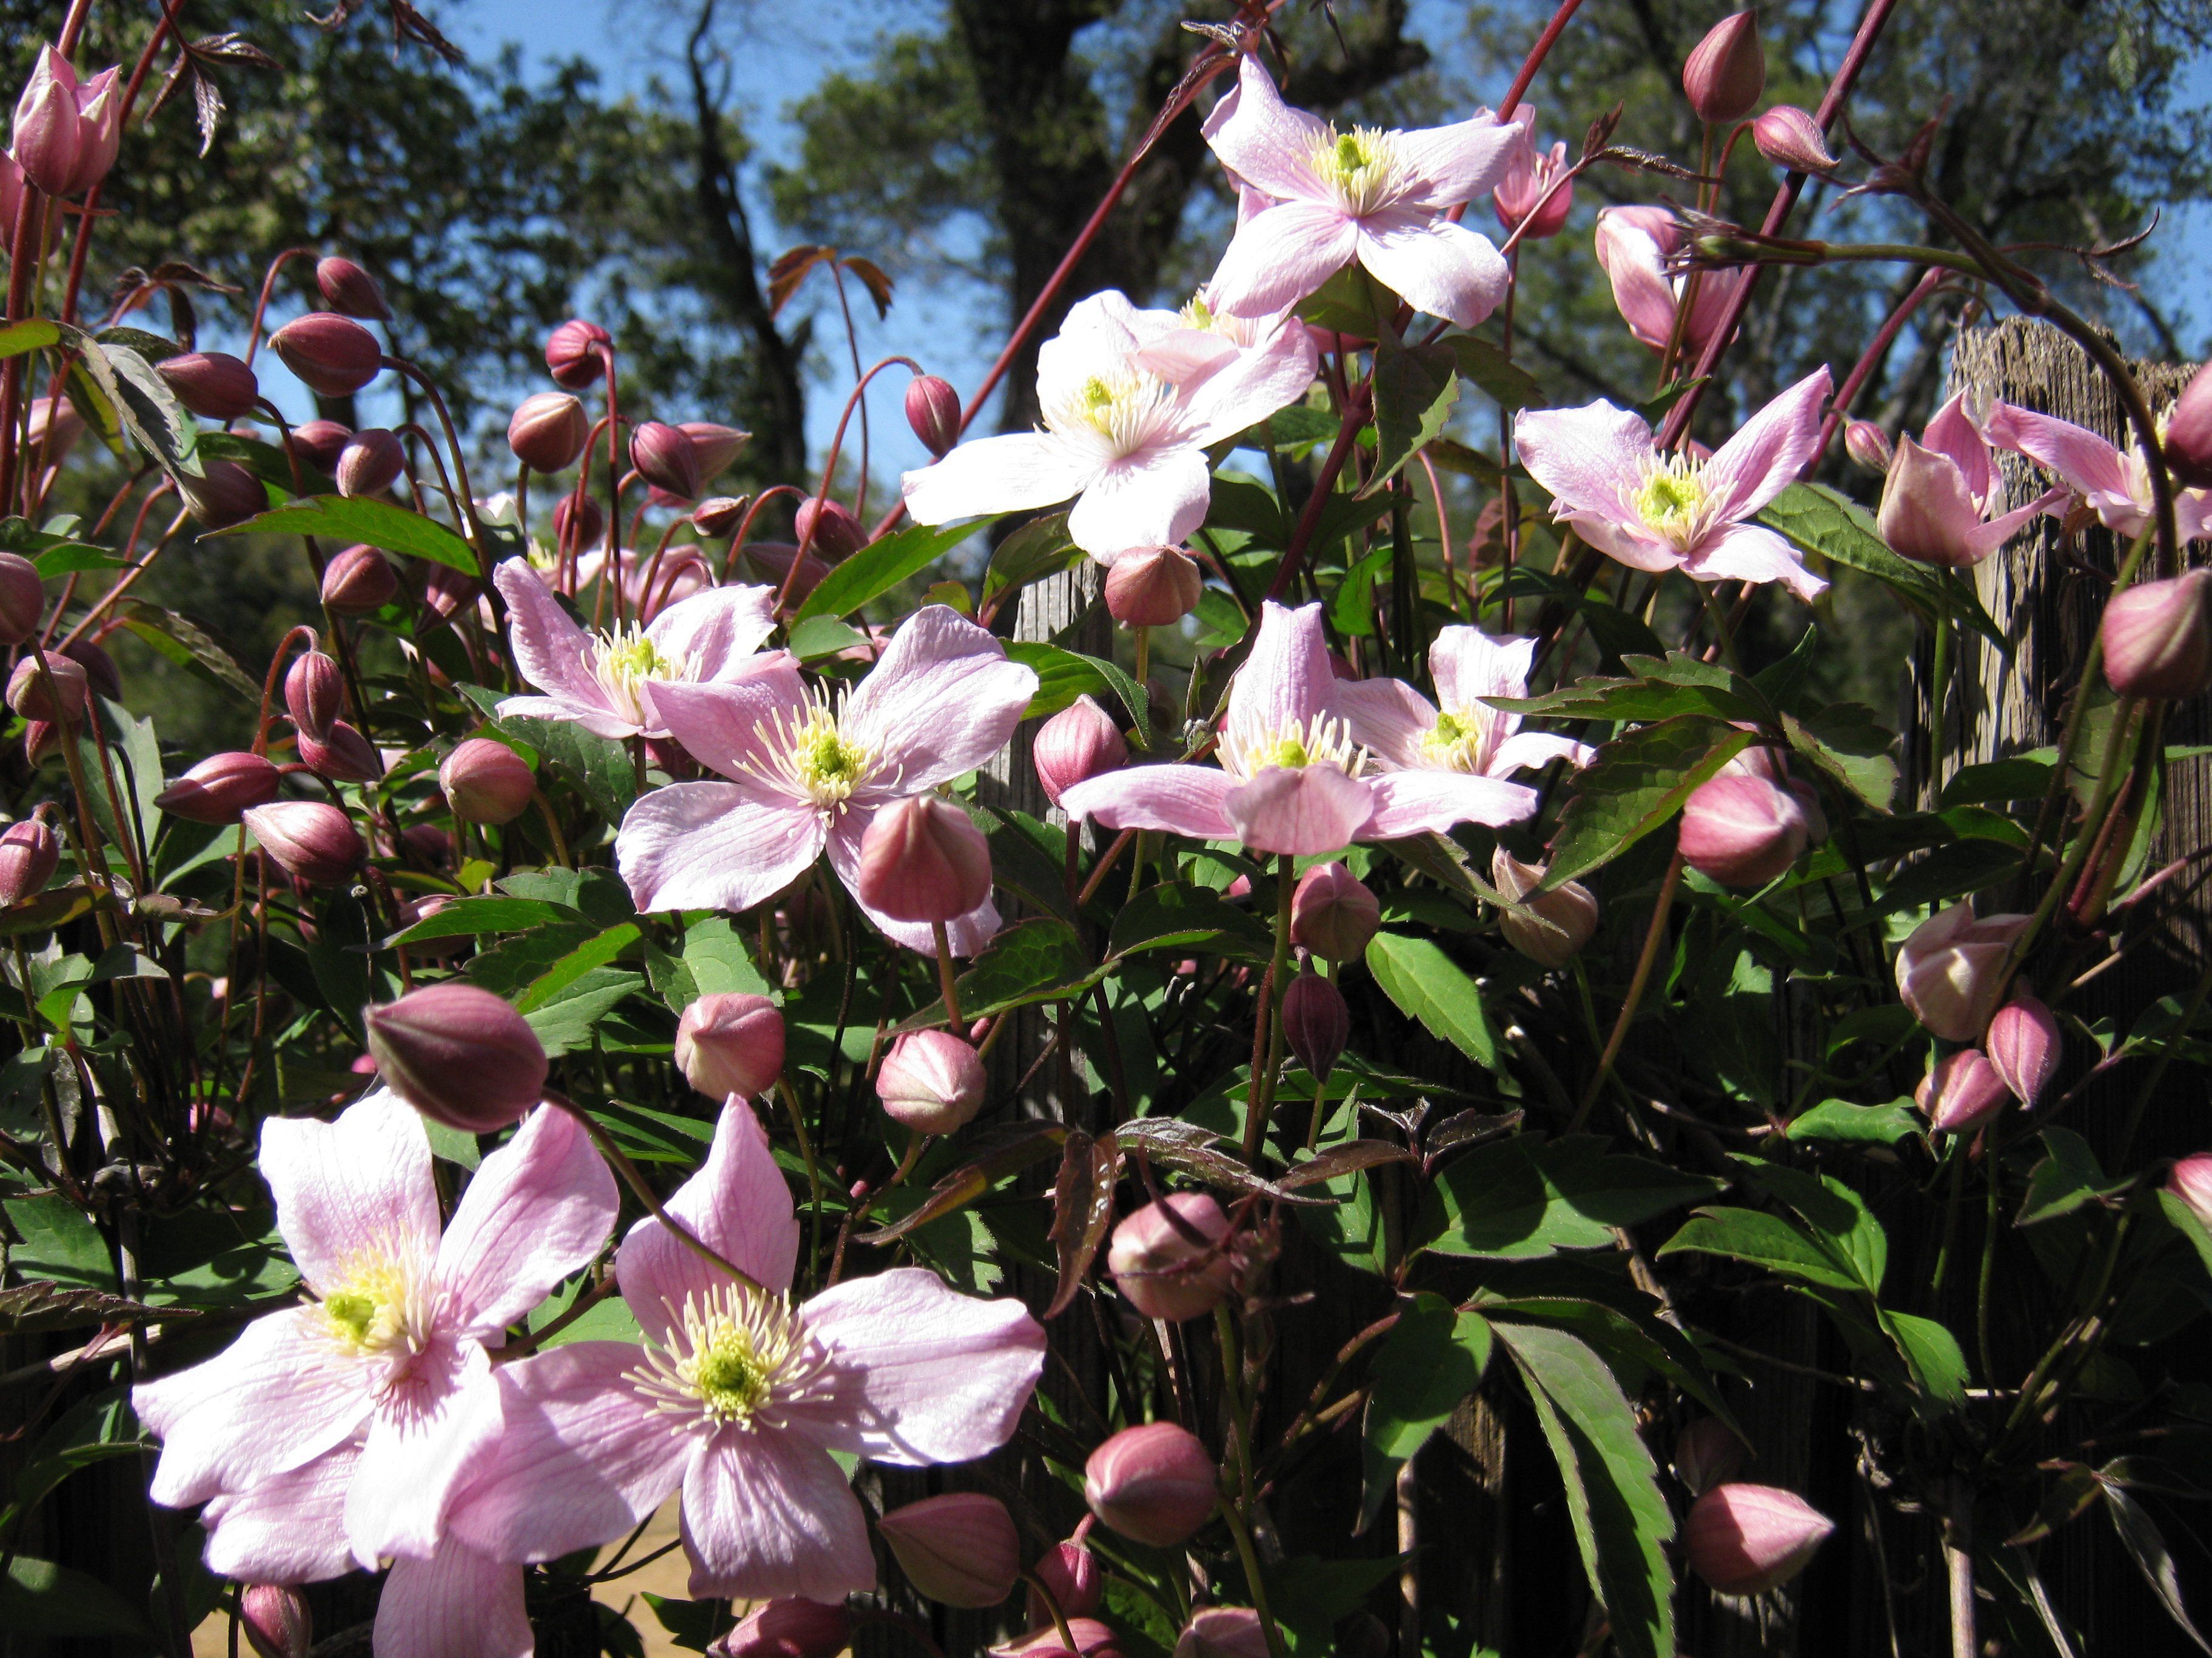

Affirmations for Friendliness

I see my friends everywhere I go.

The Universe is a friendly place and has wonderful gifts for me.

Spirit of truth loves me.

I open my heart to the truth of who I am and who I can be.

God heals me and sets me free.

The Great Spirit loves me and richly provides richly for my happiness in abundant and beautiful ways.

May my abundance reflect the beauty of the Infinite.

The vast riches of the Universe pour through me, in a vibrant expression of the elegance of Spiritual Unity.
Journaling: Fill a page with words of friendliness, generosity, and appreciation.

Get in touch with me about working further together at betty@creativevictorylifecoaching.com.

Or call me at (831)238.2626.

Action Steps for Creativity

Creativity can begin anywhere, at any time, using whatever happens to be on hand. It starts with observation.

What is it that is most obvious about where you are and what you see?


Are you happy about that?

How does it relate to you?

And, how do you relate to it?

Are you in a good position overall?

What’s the best thing about your situation right now?

How does thinking about that make you feel?

Do you see yourself as being a person who has a lot of good ideas?

Do you get excited by good ideas that other people have?

Do you get “fired up” about solving problems, or does taking action get difficult when you see obstacles appearing?

What’s the worst thing that happens to you when you take action?

Are you strongly affected by the opinions of others?

Are you often in a state of overwhelm or overly worried about results?

Do you have too much stuff hanging around, or are there big gaps between what you want and what you have?

List five reasons that you have to feel hopeful about what you have to work with, as a basis for improvements, in ten words or less.

1.________________________________________________________

2.________________________________________________________

3.________________________________________________________

4.________________________________________________________

5.________________________________________________________

From each of those reasons, pick one word that jumps out at you.

1.___________________
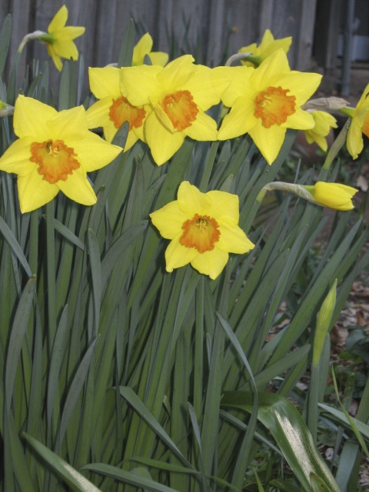

2.___________________

3.___________________

4.___________________

5.___________________

Is there a central characteristic of these words, something they all have in common?

Do they reflect an energy field that you can identify?

What color do you associate with this?

Where does it feel like hope, creative force, or energy, is located in your body? Breathe into that place. How does that feel?

What’s the worst thing about the way things are for you today?

How do you feel challenged by your situation?

Describe the emotion that you feel about this.

How does the emotion affect the way you want things to happen?

Does this seem like it’s not going to happen?

If it seems unlikely to happen, what would prevent the change from taking place?
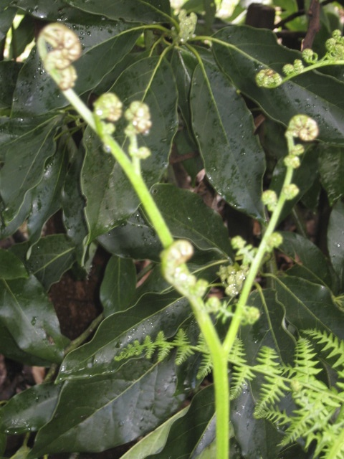
Who is involved in this with you?

What kind of relationship is it?

Who is not involved, but is important to you?

Who could help you?

What is your feeling about asking for help in a difficult situation?

On a scale of one to five, how willing are you to ask for help, where one is not willing at all, and five is ready to ask for help?

What is difficult about asking for help?

How are you able to help others? How do you feel when people ask you for help?

List seven people that you know who are important in your life, who are role models, or are in a position to help you with creating change.
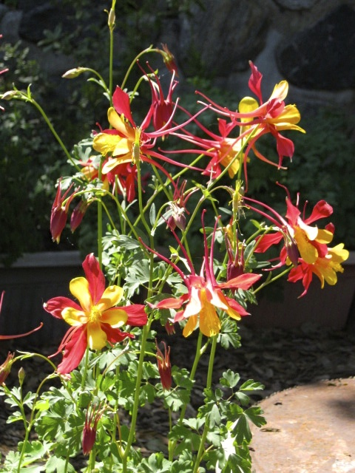
1.__________________

2.__________________

3.__________________

4.__________________

5.__________________

6.__________________

7.__________________

Are these people close to you, or removed either physically or socially?

If they are at a distance, what steps could you take to get to know them better?

What could each of them do to help you?

What would you like to accomplish as your next step in life?

What’s your long-term vision of your life in a year? Use seven adjectives to describe how you want to feel.

Five years?

Ten years?

Do you see yourself as being a clever person? Are you resourceful?

Do you think it’s wrong to change the way you relate to people in your life?

Do you feel excited by the idea of reinventing yourself?

In order to create new space in your life, it’s usually important to let go of things that hold you to patterns that no longer serve you.

Do you have things, physical objects, around you that are subtly irritating?

Do you tend to keep things because they remind you of something or someone, even if you don’t really like them?

Do you enjoy salvaging and repurposing things?

Do you have more projects going on than you could reasonably hope to complete in a year?

Are there things waiting for you to complete that you no longer are interested in completing?

Ask yourself about these, “If I had time to do this, would I rather be doing something else?”

Are there more projects hanging around than you are comfortable with contemplating?
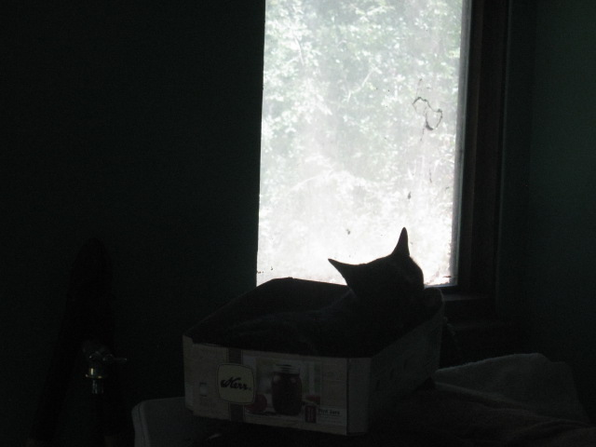

Now get curious!
Ask yourself these questions:

Who would I need to be in order to create the life I want? And what is there available, right here and now, to help me make that happen?

What parts of my story are not useful to helping me advance? How can I change my idea of who I am in a way that gives me a better story?

Where am I being too patient with things that don’t serve me?

Am I willing to take the action needed to clear my space of patterns that are not authentic to me?

How will I feel when there is plenty of room for all my possessions and I am comfortable in my space, with lots of room for creative ideas to unfold?

How will my life be different when I am creative in my responses and not living in a reactive way?
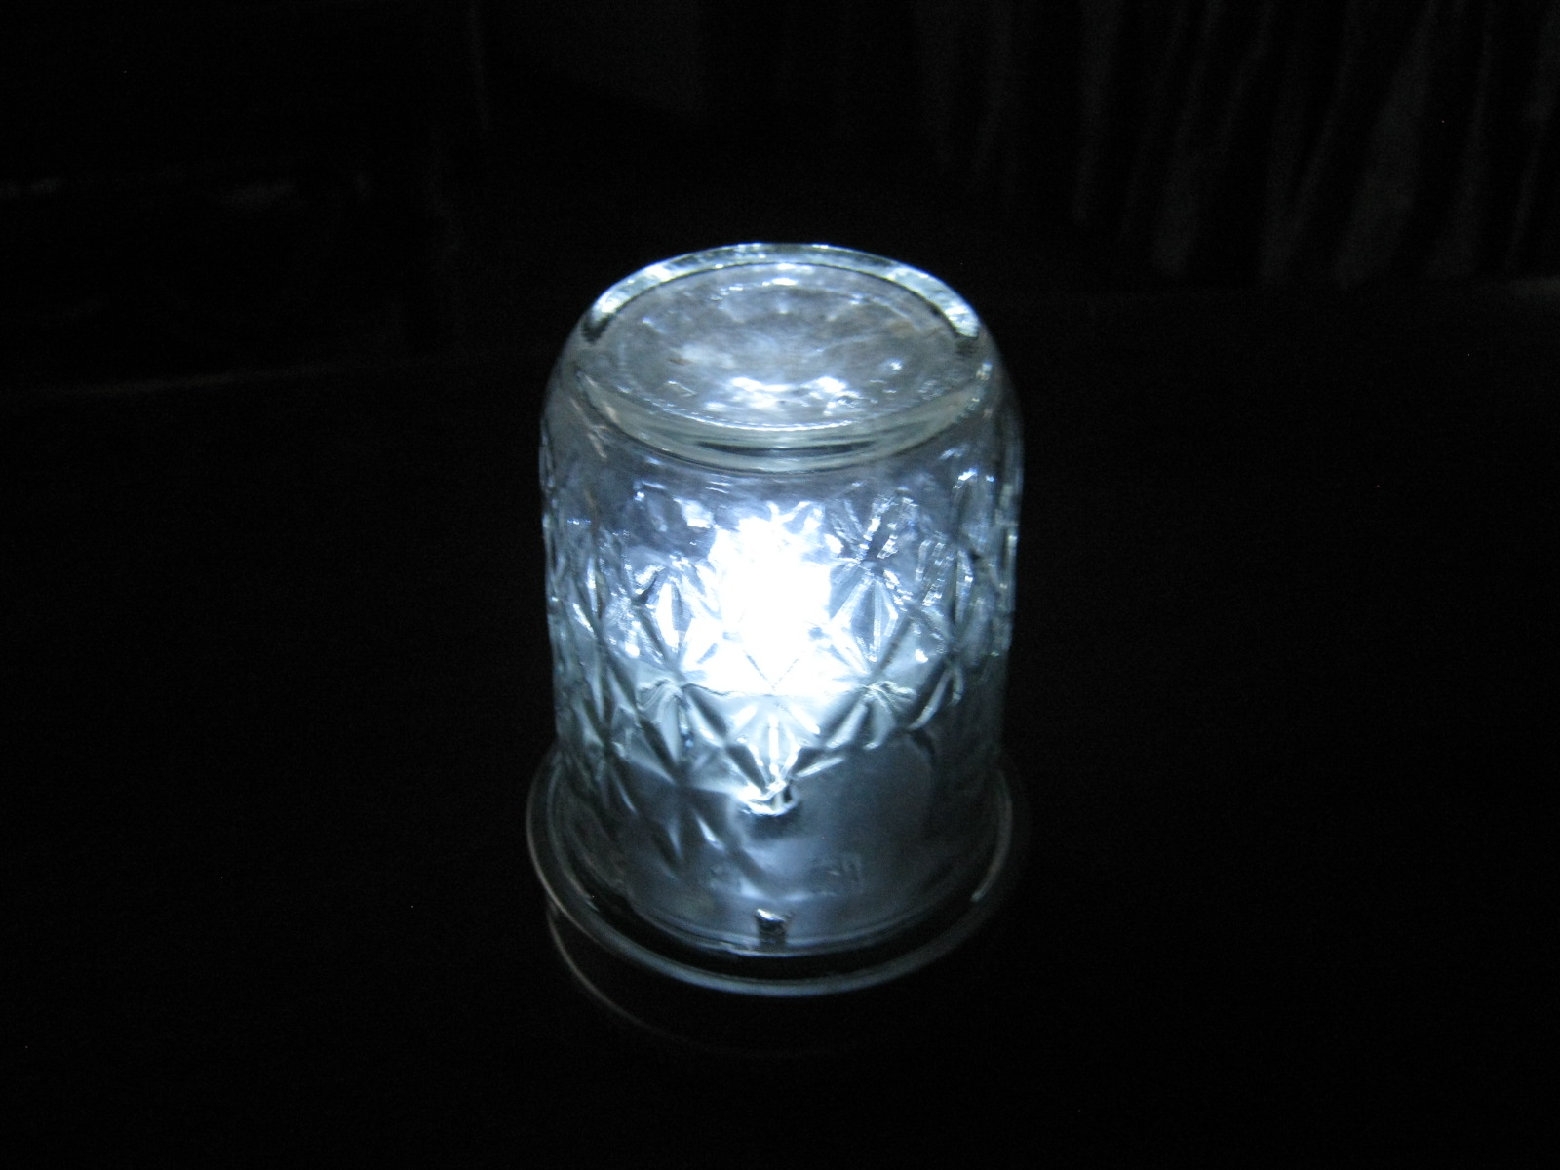

Step into that feeling now, and take action!

De-cluttering:

Get a box, and choose an odd number of things that aren’t really vibrant in your life as it is today.

These can be as small as a broken pen, or as large as your couch (you’ll need to put a picture of larger things in the box).

These objects are put aside for a period of time that you choose.

After that time, look at the box and decide what to do with the contents, allowing yourself to change your mind about what they mean to you.

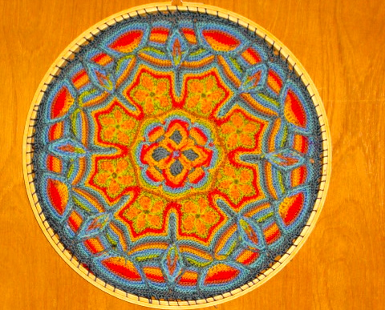

Affirmations for Creativity

Help is there when I ask for it.

Asking for help is not a sign of weakness but of intelligence.

Helping others helps me, too.

My body and mind are not subject to ownership.

My spirit is filled with the light of truth.

I welcome the help of others, and listen to my inner voice with trust.

My Inner Hero is always ready to help me.

The force of the spirit guides my movements toward that which is for the highest good.

Journaling:
Fill a page with words of energy, release, and action.

Get in touch with me about working further together at betty@creativevictorylifecoaching.com.

Or call me at (831)238.2626.

Action Steps
For
Fortitude

Fortitude:
Being With
Life on
Its Own Terms

Ah, fortitude. The most essential ingredient in the group of qualities for those who would prevail, fortitude is more than bravery. It is simple endurance made great by its encompassing qualities, its simplicity, and its inevitable victory in the end.

Fortitude outlasts all things. It’s the matter of attending to one’s duty, even at whatever the cost to one’s own comfort, safety, or even life. It’s giving freely of the gifts of spirit to those in need, and keeping to the standards that you know are right. Fortitude asks nothing of the Universe, and yet gives everything.

How do you know Fortitude in your life?

Who is there that is an example of this principle in action?

How do you express fortitude in your day-to-day living situation?

What does the idea of tending to your duty mean to you?

What difficult truths are there in your life?

Do you know someone who has made a huge sacrifice, someone that you admire?

In ten words or less, list five ways in which you understand the value of fortitude as a gift to life.

1.____________________________________________

2.____________________________________________

3.____________________________________________

4.____________________________________________

5.____________________________________________

Of these, what is the most central feature of each one, the thing that gives it meaning, in three words or less?

1.________________________
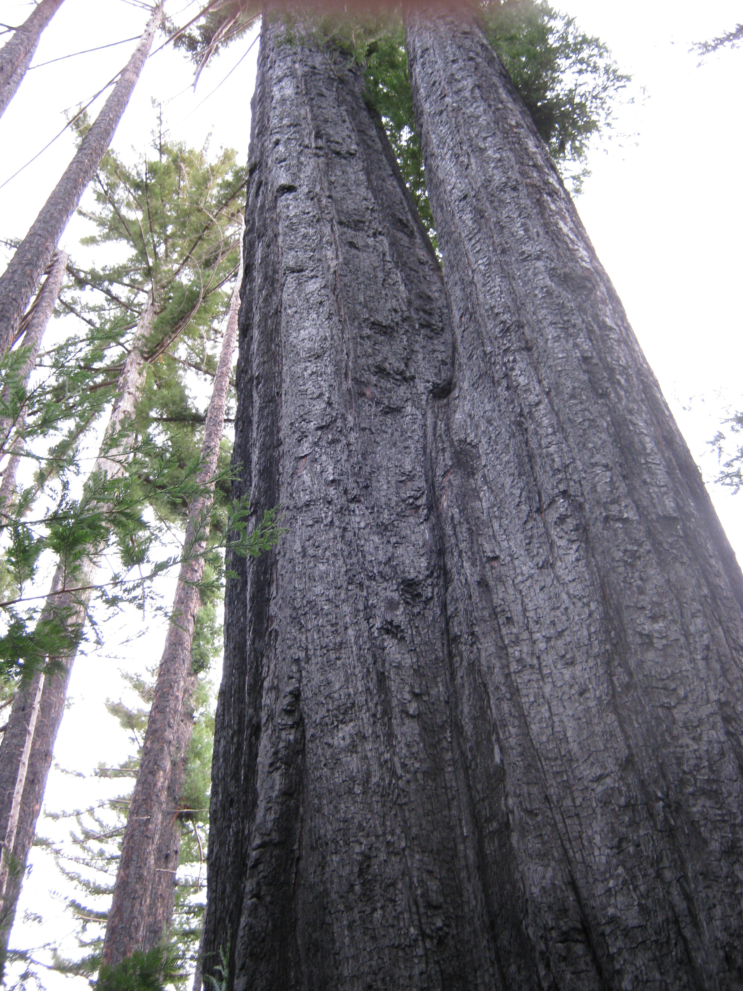

2.________________________

3.________________________

4.________________________

5.________________________

How true do you think the following statement is, where one is not true and five is really true?

“Being too attached to events or results makes people more unhappy than the events themselves.”

Do you consider yourself to be a trusting person where judging the intentions of others are concerned?

Do you trust yourself to make decisions that may have large consequences for yourself and others?

Are you in a position that requires you to do this?

What type of responsibilities do you handle on a regular basis?

Are you willing to take on things that seem to be too much for others to be ready to do? Are you required to do this?

What does the idea of being a leader make you feel, emotionally?

Do you find that you are more observant than those around you?

List five things that really scare you about your life, in five words each.
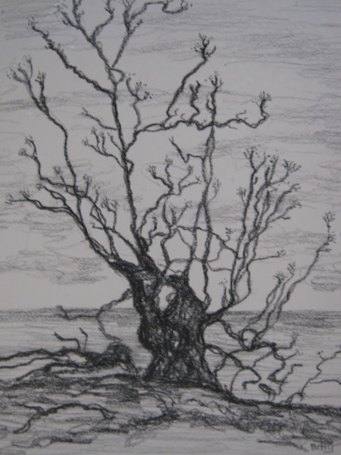
1.________________________

2.________________________

3.________________________

4.________________________

5.________________________

What is the worst thing that could happen in each of these fear situations?

1.________________________________

2_________________________________

3._________________________________

4._________________________________

5._________________________________

On a scale of one to ten, list how likely each of these is to occur. Here, one is unlikely, ten is extremely likely.

1.___

2.___

3.___

4.___

5.___

Now speak out loud to each of your fears about how they affect you. Thank them for making you more aware. Then release them.

What things have you done in life that made other people tell you that you were brave?



What things have you done that were brave, even though no one else knew about them?

Do you acknowledge the brave things you have done as being something to have as a source of pride, within your own mind?

Complete this sentence:” I wish I had been more brave when I faced___________ and I wish I had said_____________ to the challenge.”

Now cross out “I wish” (both times) and “more”.

Think about how your idea of the situation has shifted slightly.

How do you feel about this now?

What situation comes to mind that fits this new version?

What action do you think is best to handle this new situation?

How do you feel about it?

How can you accept the result of this feeling so that it changes our idea of the original meaning of the sentence?

Give yourself credit for being willing to face things that are uncomfortable!

What new possibilities can you see as a result of this shift?

Who comes to mind as an inspiration for your new actions?

Are there things in your life that are not within your direct control, and that you are really not happy contemplating?

Who would you need to be in order to let go of the discomfort, and find a way to relate to these on a different level?

Take a small step in that direction each day.

Write down your vision of yourself as a strong person who can do hard things, and look at it every day.

Draw a picture of yourself standing up for your own life.


Thank yourself for hanging in there.

Do you feel that you have a strong spiritual nature, even if you don’t say so out loud?

How are you feeling about asking the Divine to help you, asking directly?

Do you see the Divine as being a part of your life, of yourself?

When you speak, and listen to, another person, are they a mirror for you?

Do you give others encouragement with problems they are facing?

When you have to accept something that doesn’t feel good to you, how do you handle that?

Are you ready to change your idea of who you are in order to be more able to accept things?
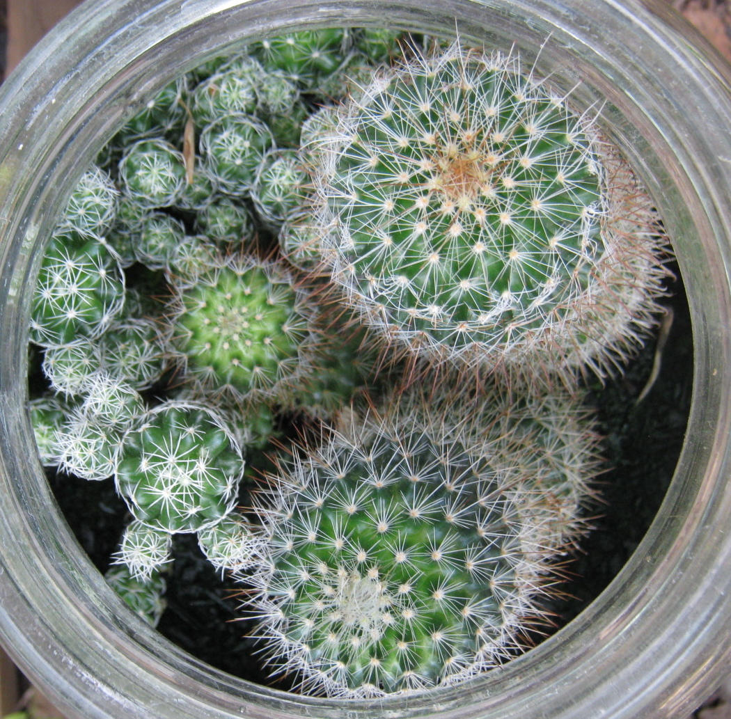
Is being “right” really important?

What does “being right” mean to you?

Are you okay with letting go of being “right” in order to be happy?

If you have to be the only one who sees what is really going on in a situation, and action is needed, and that means you will face criticism, how do you handle being in that position?

Are you ready to step out of the situation temporarily and see it as though you were not involved?

Complete this sentence:

“I am able to be brave concerning ______________________ by seeing what needs to be done and doing it.”

What does that change about your perception of it?

Go outside and take a walk for at least ten minutes. Along the way, observe places and things that express acceptance and strength. Notice where things continue to function, even if they are not in an ideal condition or state. Think about what that type of acceptance means to you.

Imagine what these would look like if their situation were improved. Imagine yourself as being the one who is able to bring about that improvement, even if it doesn’t seem like anything can be done. Who would you become in order to make these changes? What would you feel about yourself?

Affirmations for Fortitude:

Say three of these out loud at least five times a day.

It is within my ability to accept and allow that which does not make me happy or which appears to be inconvenient, without needing to change it to fit my own ideas.

I am ready to listen to what Life has to say with an open heart and mind.

When I forgive a person, I let their actions go, to be judged not by me but by time.

There are some things that are beyond my personal ability to make right.

I cannot be made less by any circumstance.

I walk in beauty and harmony with trust and inner peace.

Vast dignity is contained within my being and I express it in a loving way.

Journaling: fill a page with words of trust, acceptance, and forgiveness.

Get in touch with me about working further together at betty@creativevictorylifecoaching.com.

Or call me at (831) 238.2626. Be strong, and know that you are able to do good things in life.

Perseverance:
Traveling
The
Path

Action Steps
For
Perseverance


Just about any kind of success depends on sticking with it. In fact, that’s the single biggest factor in learning to prevail. For it is a skill to see that by being with yourself honestly and truly, and sticking with your knowledge of how deep and true you really are, you will win the day in the end. Really all you have to do is to know that what you are saying, what you are doing, is real, dig down into that reality, and take the gift of perseverance for your own.

How much of what you are feeling today is true to your own vision of how you want your life to be?

Whose ideas led you to the place you are now?

What are you enduring, day by day?

Where do you see yourself as being in the future when you continue to endure these things?

Which ones are worthwhile, and which are not, in terms of creating a fulfilling reality for you and those you love?

Do you endure things because you want to please others, even at the cost of your own happiness?

List seven things you are enduring, in five words or less.

1.____________________________________

2.____________________________________

3.____________________________________

4.____________________________________

5.____________________________________

6.____________________________________

7.____________________________________

Now circle one word from each of these that has power in your mind and feelings.

What is the common theme between them?

Which one is the hardest to deal with, and what is the word bringing up for you within your body?

What color is it?

Where is it located in your body?

How can you make that feeling work for you, instead of against you?

What decision is waiting for you in this?

Are you giving yourself credit for sticking with the situation, or are you upset about it?

How does the story you tell yourself about the situation influence the nature of your experience in perseverance?

In what way does your story fuel your inner needs for recognition?

Who serves as an example of perseverance for you?

What makes them admirable?

How was their greatness magnified by the difficulties they had to face?

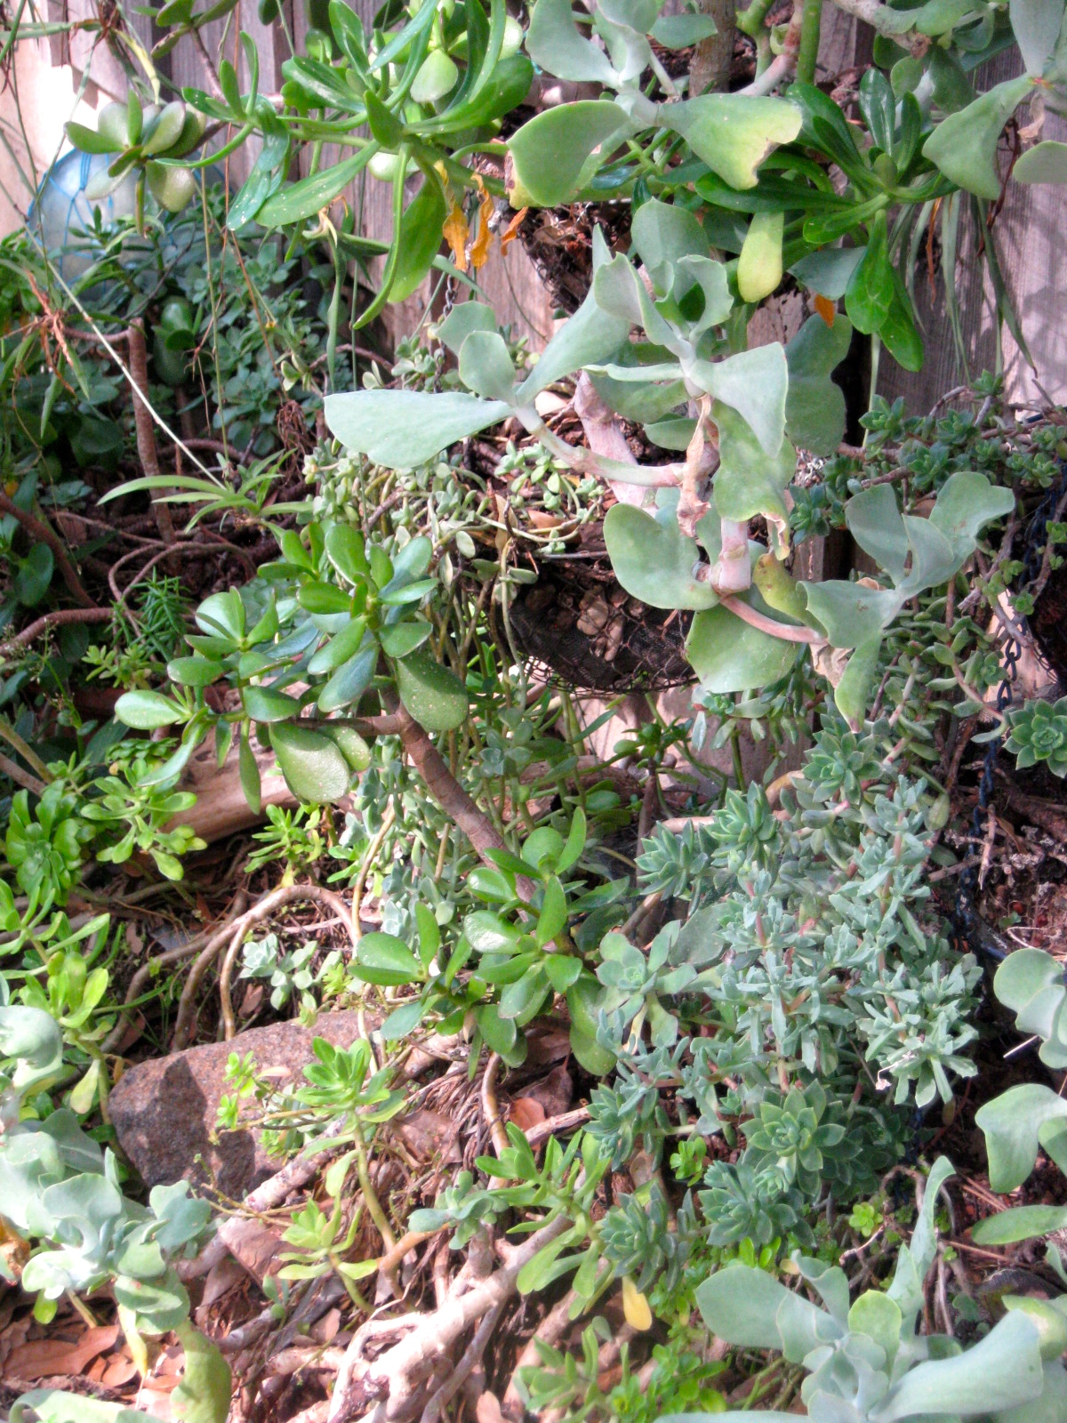
What do the words “hang in there” bring up for you when you hear them?

Think of a time when things were really hard for you, and you kept going anyway.

What feeling do you have as you think of it?

Why did you keep going instead of not doing so?

How do you define when it is time to let go of an idea, a situation, or a relationship?

What, for you, is the definition of defeat?

What’s the definition of giving up?

What is the difference between those two things?

Think of a time when you admitted defeat. How were you released from difficulty by doing that?

Think of a time when you gave up. How did you feel about that?

In what way is it possible for you to change the story about giving up, in your mind, and change the way you feel about that time?

It’s your personal power that is invested in this story. Whose idea about who you are is made powerful by your story? Is this a good thing for you?

If you feel bad about “giving up” on something, it might be okay to view it instead as a simple defeat that allows you to rise again, for something that is more in tune with your inner good.

Are you willing to make that distinction?

Who would you be, if you were not blaming yourself in the situation?

If you stand in that feeling, how do you see the experience?

Complete this sentence: “It was the _________of something that is__________for me, and I am made stronger by knowing this.”

Notice how the words you chose affect your perception of what happened.
Think of a time when you kept going now matter what, and what that felt like for you.

What are your top priorities to create a space in which you clearly know that you have taken control of your energy? List five. These should be from different areas of your life.

1.______________________________

2.______________________________

3.______________________________

4.______________________________

5.______________________________

What one action can you take on each of these today that will lead to a next step tomorrow?

1.______________________________

2.______________________________

3.______________________________

4.______________________________

5.______________________________

What will be the result when you continue to take these steps on a consistent basis?

Do you share your perseverance stories with others?

Are you able to just soldier through on your own and feel proud of that?

Is taking your story to a group a good experience for you, or do you feel self-conscious about letting others know that you have things in your life that are hard to handle?


Do you give yourself credit for the help you have given to others by listening to them, whether or not they appreciated you for doing that?

How often do you find that what you are doing is not as rewarding as you want it to be?

What’s the place where you would jump out of the situation for something that you enjoyed more?

Think of a new habit that you would like to create in your life, something simple that takes only a few minutes a day.
Write yourself a little promissory note from that habit that says, “I promise to pay five minutes a day to (new habit)”, for (period of time, three weeks is best) This is NOTE #1.

Post it where you will see it often. You can also add what time of day this is to be paid, if you like.

Now write another promissory note that says, “I promise myself _____(something you want) when I fulfill NOTE #1”.
This is NOTE #2.
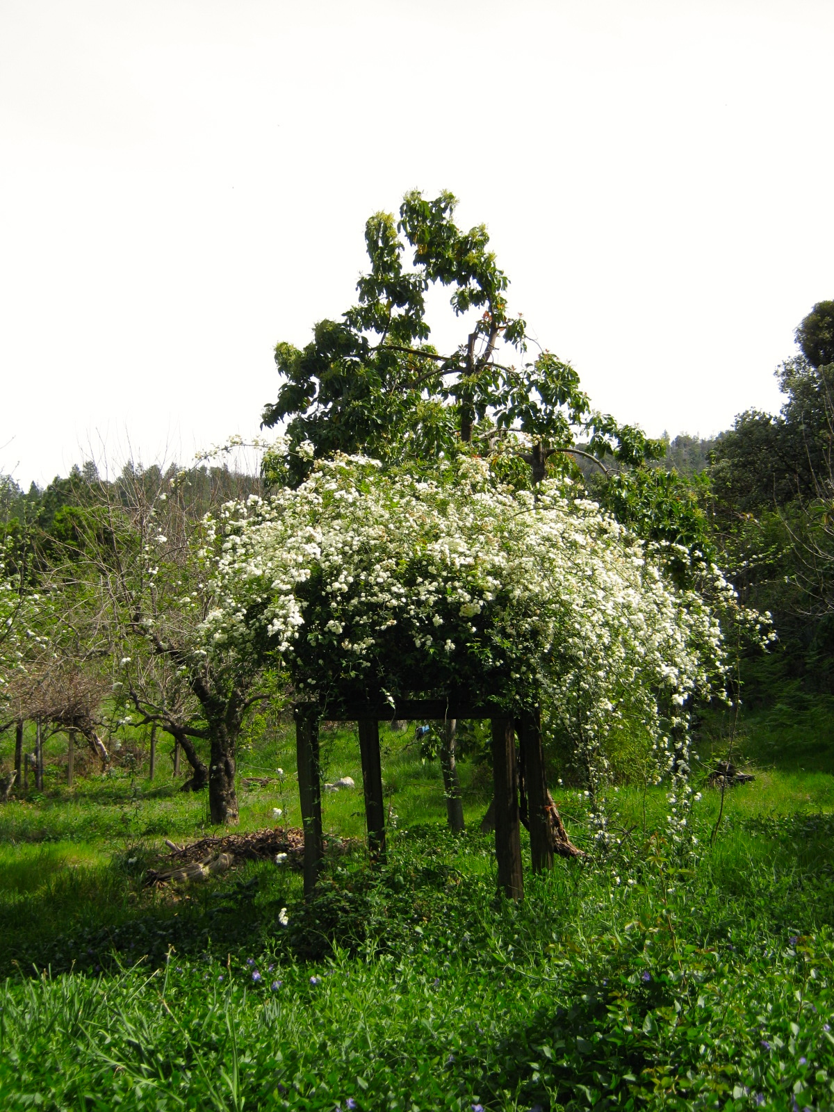
Post it in a different place.

Now for NOTE #3. “I promise to be there for myself in honor and trust, whether or not I keep my promises in NOTE #1 and 2.”

You’ve got it covered! Since you are not taking the whole thing too seriously, your chances of keeping your promises improve.

However, you are still committed to keeping NOTE #1 as the doorway to NOTE #2. Deal?

Journaling: fill a page with words of perseverance, continuity, commitment.

Affirmations for Perseverance: Say three of these aloud, five times a day.

Faith is the uplifting force, which leads to greater focus.

Perseverance is the doorway to prudence.

The beauty and power of my approach to success is directly inspired by the sustaining love of my co-creator, the higher mind.

I walk in beauty and harmony with trust and inner peace.

Vast dignity is contained within my being, and I express it in a loving way.

My focus and attention are directed through the careful guidance of the growing and rich substance, which lives within all things.

Limitation is overcome and transformed, by the perseverance of my awakened mind.

I remain receptive to the voice of the spirit, which guides my movements through that which is for the greatest benefit for my potential.

I recognize and honor the power of the true force of Spirit, which is the life of the universe.

Journaling: fill a page with words of perseverance, continuity, and grace.

Get in touch with me about working further together at betty@creativevictorylifecoaching.com.

Or call me at (831) 238.2626.
Keep going on your path! May it always be lit.

Completion:
Celebrating
The
Harvest

Action Steps for Celebrating
The
Harvest
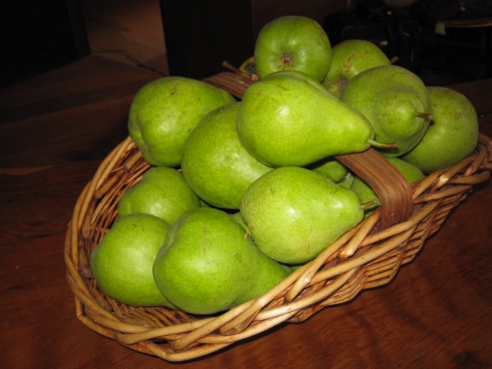
Completion is the crown of the victor. When things become complete, they are transformed from mere projects into realities that are tangible, and that produce results. Many people find that completion is a really difficult thing to accomplish, and it often is. Yet without it, the motivation you have so carefully built will leak away and dissipate like vapors on a warm morning.
And, when you HAVE completed your goal, it’s time to celebrate that fact, and acknowledge what has happened.

What have you completed lately that makes you really happy?

What things are there in your life, today, waiting for completion?

How will you know when they are completed?

What feeling do you anticipate having when you have completed these?

Who will benefit from this completion, and in what way?

Are there things you are putting off completing, either by choice or by necessity?

What would it be like if you stopped putting them off?

Are there things that you now see don’t need to be completed, based on changes in the way you feel since the time you began them?
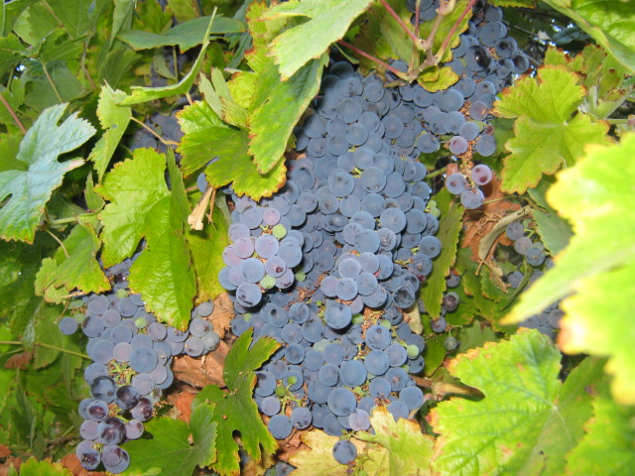

What will happen if you don’t complete them?

List seven things or feelings that are present in your awareness around the concept of completion. Use ten words or less.

1._________________________________________________

2._________________________________________________

3._________________________________________________

4._________________________________________________

5._________________________________________________

6._________________________________________________

7._________________________________________________

Circle the word in each description that has the most meaning for you. What is the common theme among them?

When you have completed a task, the energy you invested in it returns to you in a new form. There is a transformation from one energy level to another that will change how your experience feels.

Think about the change in form that each of the above statements has hidden within it.

What kind of energy flow is shown by the change in form? Is it making your round of experience richer and more meaningful as you complete this change?

Completion also implies an ending, and a new beginning. What challenges will arise in your life as you complete the things you are working on now?

What new opportunities will you have?

Completion means cleaning up after the work of building, and a celebration of what has been done.
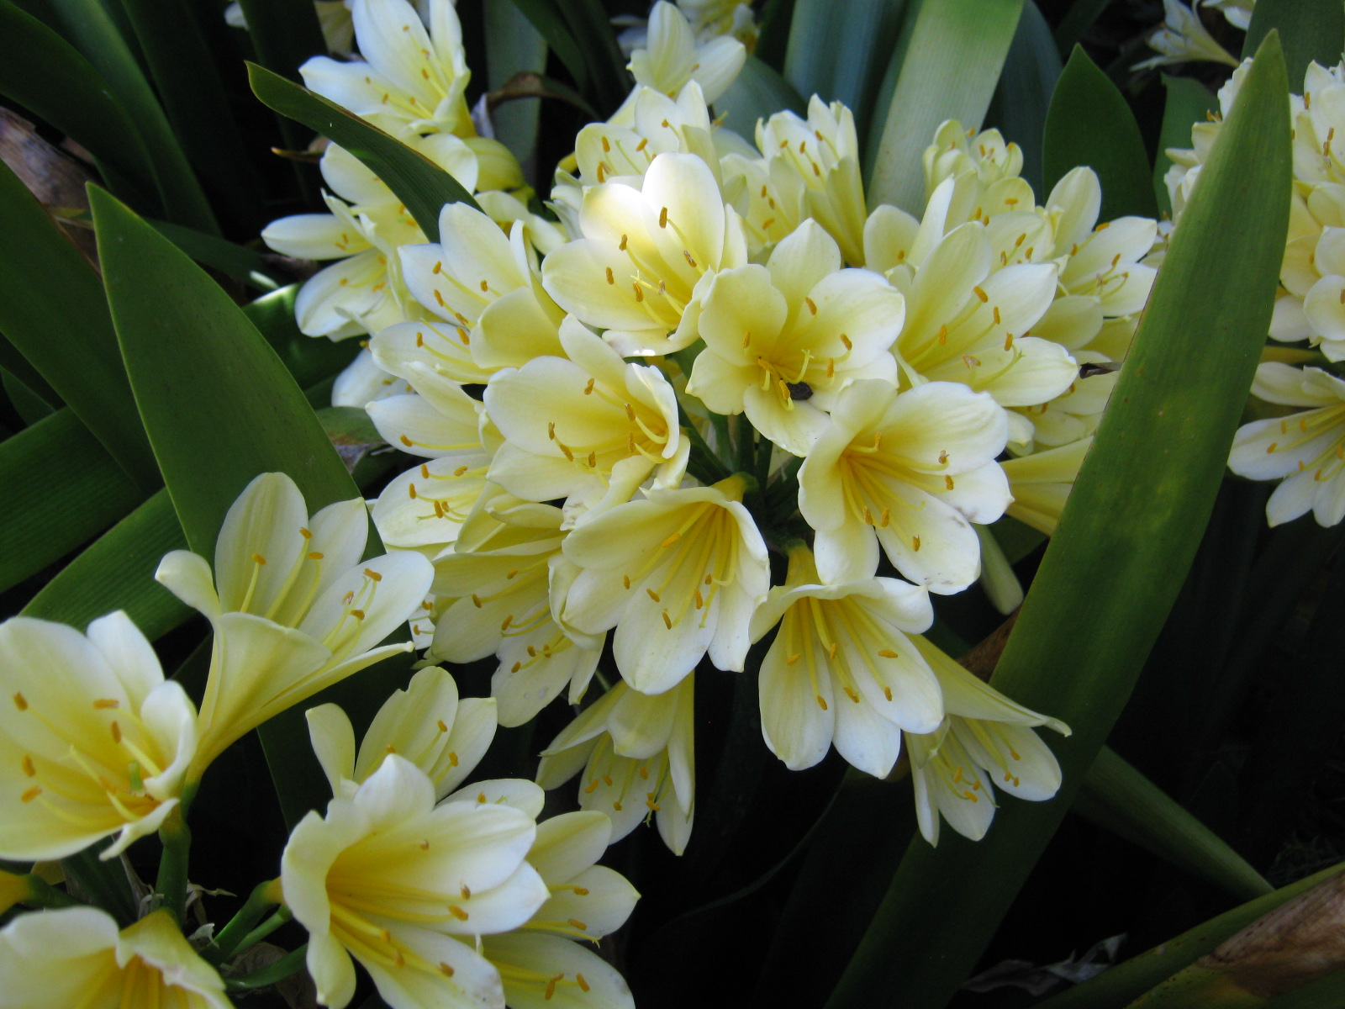

What can you clear out of your life today to make room for more celebrations?

Are you holding on to things that don’t allow you to complete energy that you have invested your time, emotion, and even money in? These can be emotional patterns, relationships with people, places, or things, ideas about yourself that don’t make you feel good.

Which is greater, the pain of letting go of those, or the pain of staying in a place with your goals and desires just out of reach?

How will you feel if you don’t complete the things you really want to do?

How can you change your relationship to those things that hold you back, so that you can complete the important goals that you have set for yourself?

Who will you need to be in order to make that happen?

What will you say ”yes” to, and what will you give the answer of “no”?
List five “yes” answers.


1.__________________

2.__________________

3.__________________

4.__________________

5.__________________

Why is each of these worthy of a“yes”?

Now, list five “no” answers, and the reasons why “no” is right.

1._________________________

2._________________________

3._________________________

4._________________________

5._________________________

Who will be able to celebrate each of these decisions?

What energy will be freed up by them?

How can you make use of that new field of energy to create more freedom in your life?

Who are the people that you want to invite to join in your celebration of freedom? How will they be able to enjoy what you have created?


As you step into your new vision of what your life can be, you are taking on a new kind of self-worth, and advancing on the Bridge of Spirit to your True Hero Self.

How can you express this truth most fully, and with the highest level of confidence that what you are doing benefits everyone?

What kind of sharing and responsibility is there for you now, in your life, that can bring you happiness and joy?

In order to enjoy the fruits of life, you first have to pick them. What fruits of life are ready for you today?

Which will need to ripen more before they are ready to pick?

What will be needed in order to take care of them once they are harvested?

What are you ready to do, now, to make what you have accomplished something that others can enjoy, too?
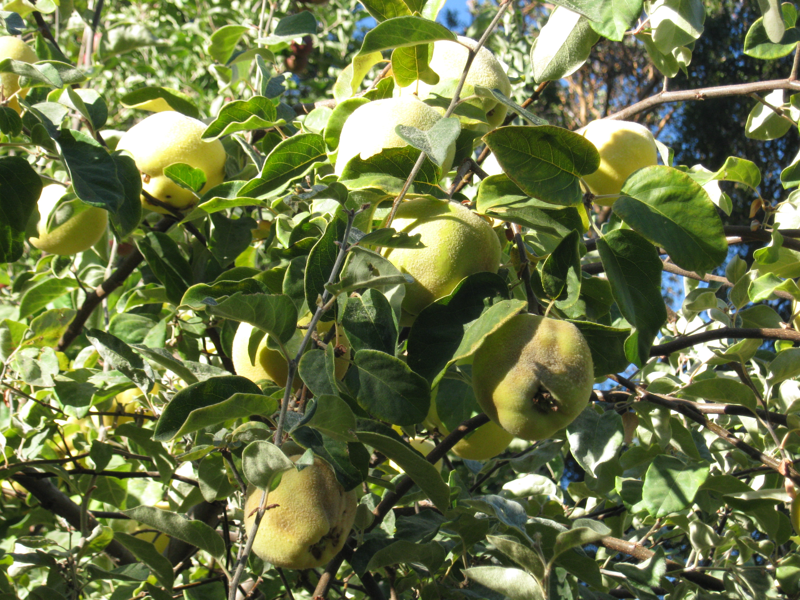

How will this make your own experience richer?

Who will you be able to help?

Complete this sentence:
“Now that I have accomplished____________, I know that I am strong enough to do____________.
Affirmations for Celebrating the Harvest:

Everything that has happened has a purpose.

What is within me is beautiful and complete.

I have strength far beyond what I ever knew.

My life is full of opportunities and beautiful experiences.

People are happy to see me doing so well.

It feels wonderful to have so much to give.

My path is always lit.

Journaling: fill a page with words of completion, accomplishment, and celebration.

Please get in touch with me about working together by sending me an email at betty@creativevictory.com.
Or call me at (831)238.2626.

All the best! May you have health, love and wealth, and the time to enjoy them.

Betty Withrow

